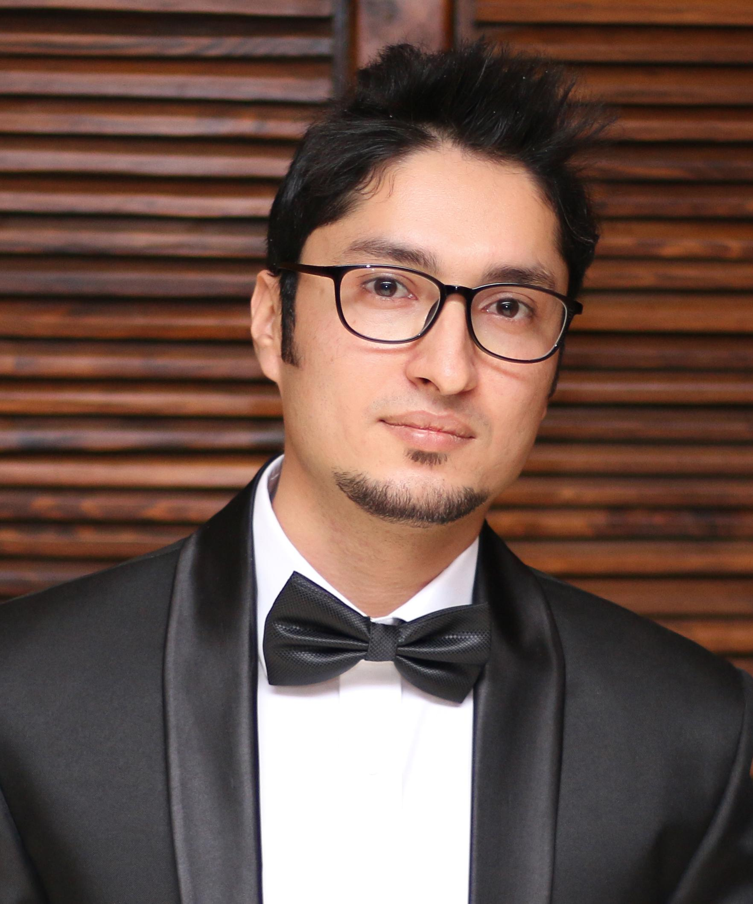
Curriculum Vitae
Name: Muhammad Jamil
Marital Status: Single
Nationality: Pakistani
Cell Number: 0092-3369290233
Current Address: Street # 162, House # 243, G11/1, Islamabad, Pakistan
Portfolio Link: http://www.nanodesignz.com/
E-mail: Jamil.mughal77@gmail.com

Objective

To give my best performance as a team member and alone, to achieve organization’s primary goal.

10 years of Experience

Currently working as a Senior Web Designer (UI/UX) at Emcentrix (USA):

I am working as a Senior Web designer and UI/UX designer in Emcentrix. Where my responsibilities are to make HTML/CSS (DIV based) and HTML5 / CSS3 responsive designs for Desktop, Ipad Mobiles, and all kinds of devices. Also over here, I am responsible for making web forms and websites by using bootstrap that handles responsive designs. I am also responsible for Handling jquery plugins, Logo designing, desktop application designs, print media designs and all kinds of graphic stuff.
Duration: (From April 31st 2015, to Current)

Worked Part time as a Senior UI/UX Designer at NAVSON Limited (UK):

I worked as a Senior UI/UX designer in NAVSON Limited, UK. Where my responsibilities were to create designs for web products which were responsive for IPAD, Iphone and all kinds of devices. Also, putting all the tools together to make a nice and flexible web product. Handling jquery plugins, Logo designing, desktop application designs, print media designs, photography etc.
Duration: (From July 1st 2015, June 1st 2016)

Worked as an Assistant Manager UX-UI Design (Product Development) at Earth Factor, Islamabad:

In Ibex I was working in the fields of Mobile Value Added Services (VAS) and M2M Communications for Multiple Mobile Network Operators (Local and International) enterprises and consumers. My responsibilities were to ensure consistent production for web or mobile application products by using design standards. Sketching and storyboarding with high level design skills and aptitude. Conceptualize and articulate ideas, prototypes, persona and scenarios to drive decisions. Delivered user experience requirements, including wireframes and high-fidelity prototypes based on customer behaviors and needs.
Duration: (From April 24th 2014 to April 30th 2015)

Worked as a Senior Web/Graphic/UX-UI designer at ESOLPK, Islamabad:

I worked as a Senior graphic designer and web designer in ESOLPK, Islamabad. Where my responsibilities were to make website/Mobile/Ipad designs from scratch and convert it from PSD to HTML/CSS (DIV based) and HTML5 / CSS3 responsive designs for IPAD, Iphone, and all types of devices. also putting all the tools together to make a nice looking site. Handling jquery plugins, Logo designing, desktop application designs, print media designs etc.
Duration: (From October 1st 2012 to April 24th 2014)

Worked as a Web/Graphic designer at TechnoDigg, Islamabad:

I worked as a graphic designer and web designer in Technodigg, where my responsibilities were to make website designs from initial and convert it from PSD to HTML/CSS (DIV based), Handling jquery plugins, Logo designing, Desktop application designs, etc.
Duration: (6 Months Full time)

Worked as a Web/Graphic designer at Software Pattern, Islamabad:

I worked as a web designer and graphic designer in software pattern, where my responsibilities were to make website designs from scratch and convert it from PSD to HTML/CSS (DIV based), Logo designing, Desktop application designs, etc.
Duration: (7 Months Full time)

Worked as a Web Designer/Web developer/Graphic designer at Software House (Websolutnz):

I worked as a web Designer/Developer and Graphic designer at a software house to lead the team. My fields of work were in developing websites, graphic designing, and customer services. I was a professional Logo designer too over there. I gain a lot of experience over there. And now I feel myself as a professional.
Duration: (4 Months Full time)

Worked as a Print Media designer (Black Art), Pvt (Part Time):

I have professional experience of 2 years at a marketplace with Black Art (Pvt) as a Print media designer, where my responsibilities were creating Panaflex designs, Brochures, Professional Logos, Visiting cards, Letterheads, Offset printing designs, and any kind of designs related to printing.
Duration: (2 years as a part time)

My Portfolio:

See my online portfolio on this link http://www.nanodesignz.com

Made other professional website templates for International and local clients. Will Provide links on demand.

Education

Bachelors of Software Engineering (BE Hons), From City University Of science And Information Technology Peshawar

Degree | Institution
Software Engineering BS.SE (HONS) | City University of Science And Information Technology Peshawar
HSSC (F.Sc) | City College Of Arts And Science Shahi Bagh Road Peshawar, (Peshawar board)
SSC (Matriculation) | Fazaia Inter College, Shaheen Camp Peshawar, (Federal board)

Computer Skills:
Web Designing (Bootstrap, HTML5, CSS3, CSS , Java Script, Jquery, Dreamviewer)
Graphic Designer (Working in Corel Draw, Adobe Photoshop Suit, Illustrator, Logo designing)
Mobile App Designing (For Android and Iphone)
Print Media Designing (flyers, brochures, book covers, banners, branding etc)
Sketching (Digital pencil sketching, Painting)
Photography (Photo manipulations, Raw editing)
Microsoft Office.
Languages:
1. English, (Read, Write, Speak) 4. Hindko, (Speak)
2. Urdu, (Read, Write, Speak) 5. Punjabi. (Can understand and speak)
3. Pushto, (Read, Speak)

